Before configuring web server you have to make acl which is in firewall folder this is a follow up after that,
First static ip for dmz web server,
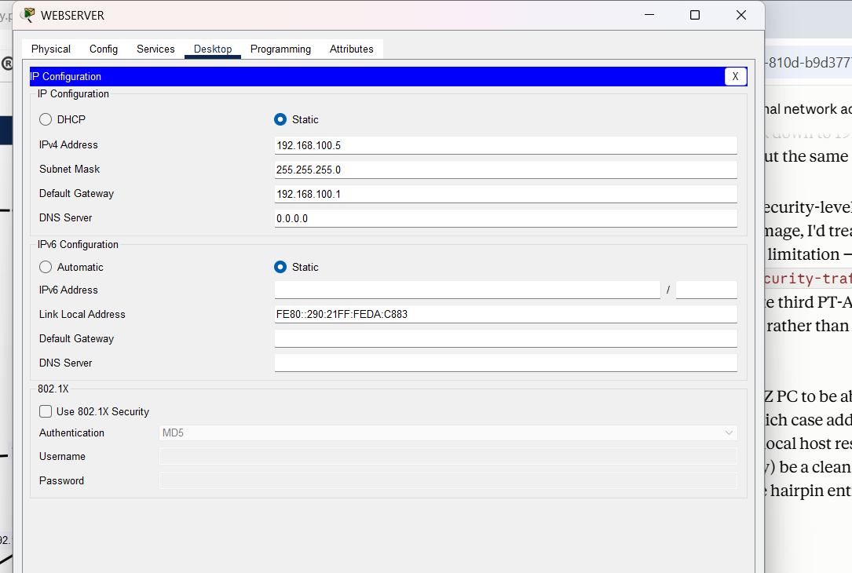
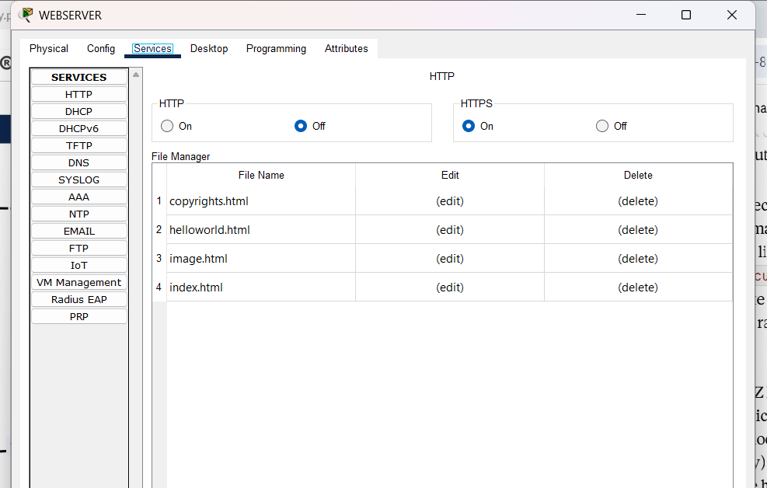
turn on https service ,
simple now you can access from inside and outside network using https://60.60.60.3 I have already configured nat and nathairpinning for this. Lets check from outside network.
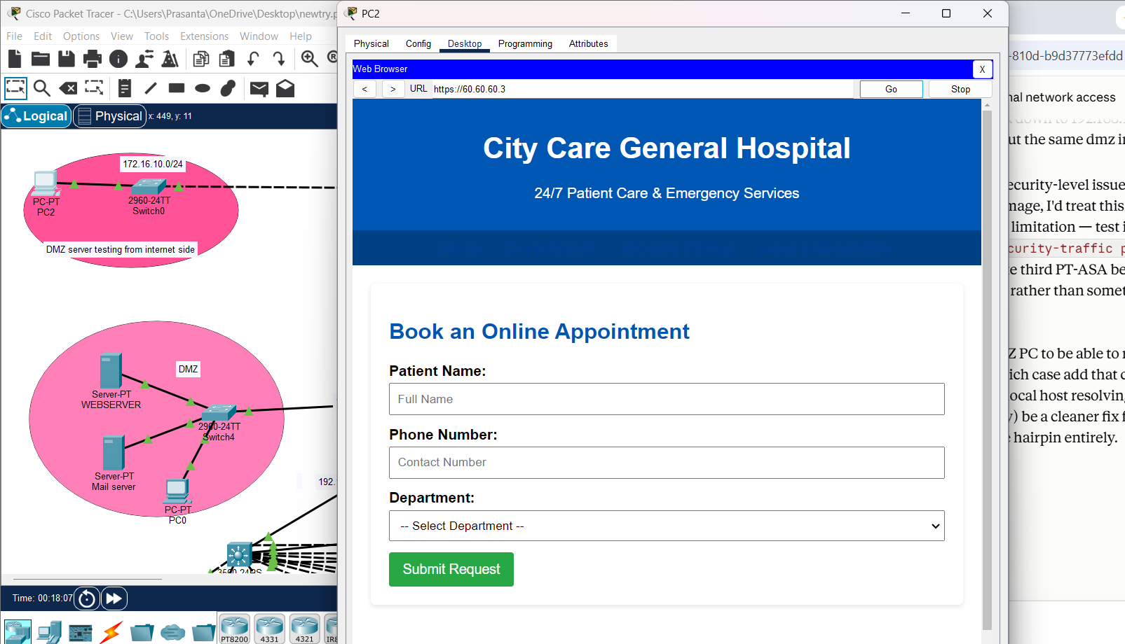

I have used ai to make website you will get default website from packet tracer.
lets test from inside network,
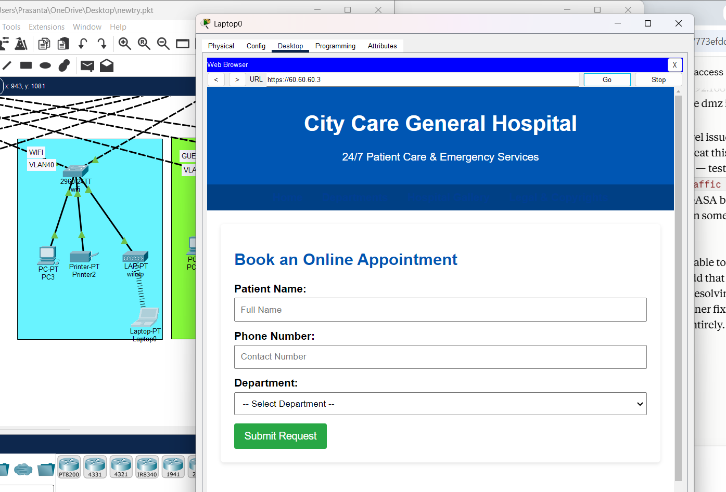
Note: for inside network only vlan 20,30,40 and 50 are permitted.
These are done through acl interface vlan so you wont find that acl in firewall its done in mls.

